<https://www.youtube.com/watch?v=0HXcK-yJS7w&list=PLJ4k1IC8GhW1xK5YEkiYdbWiOiXHMZyen&index=9>

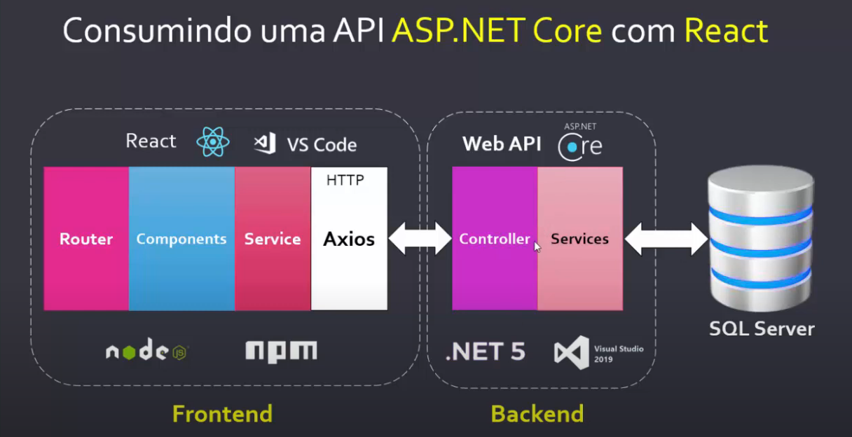

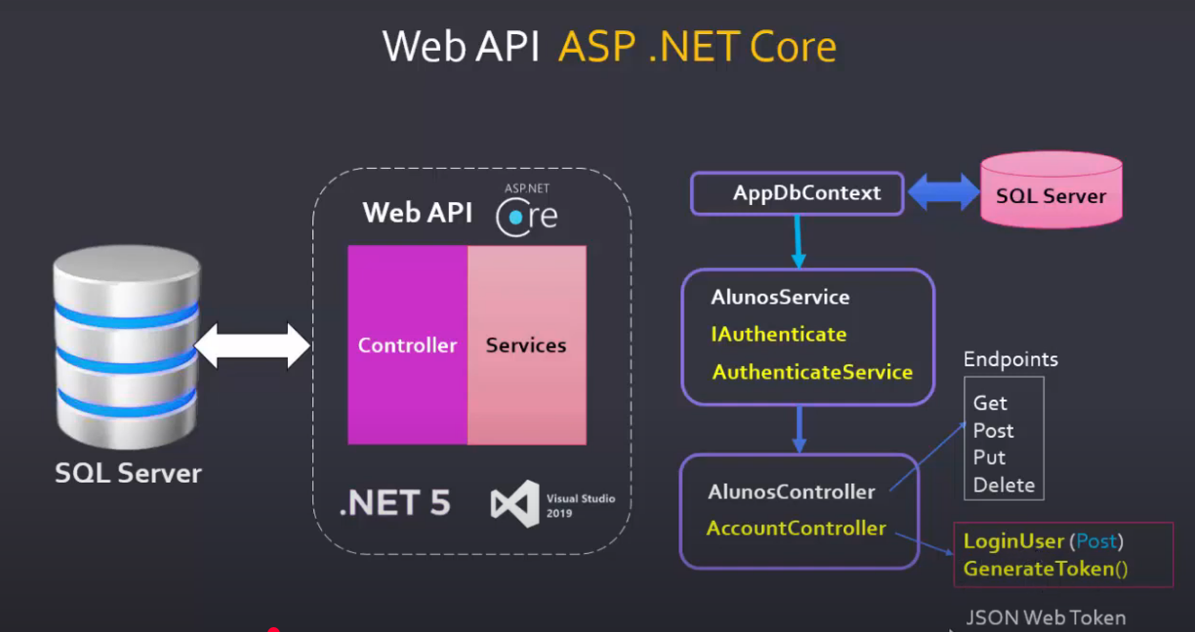

Fluxo:

